Tic tac toe:
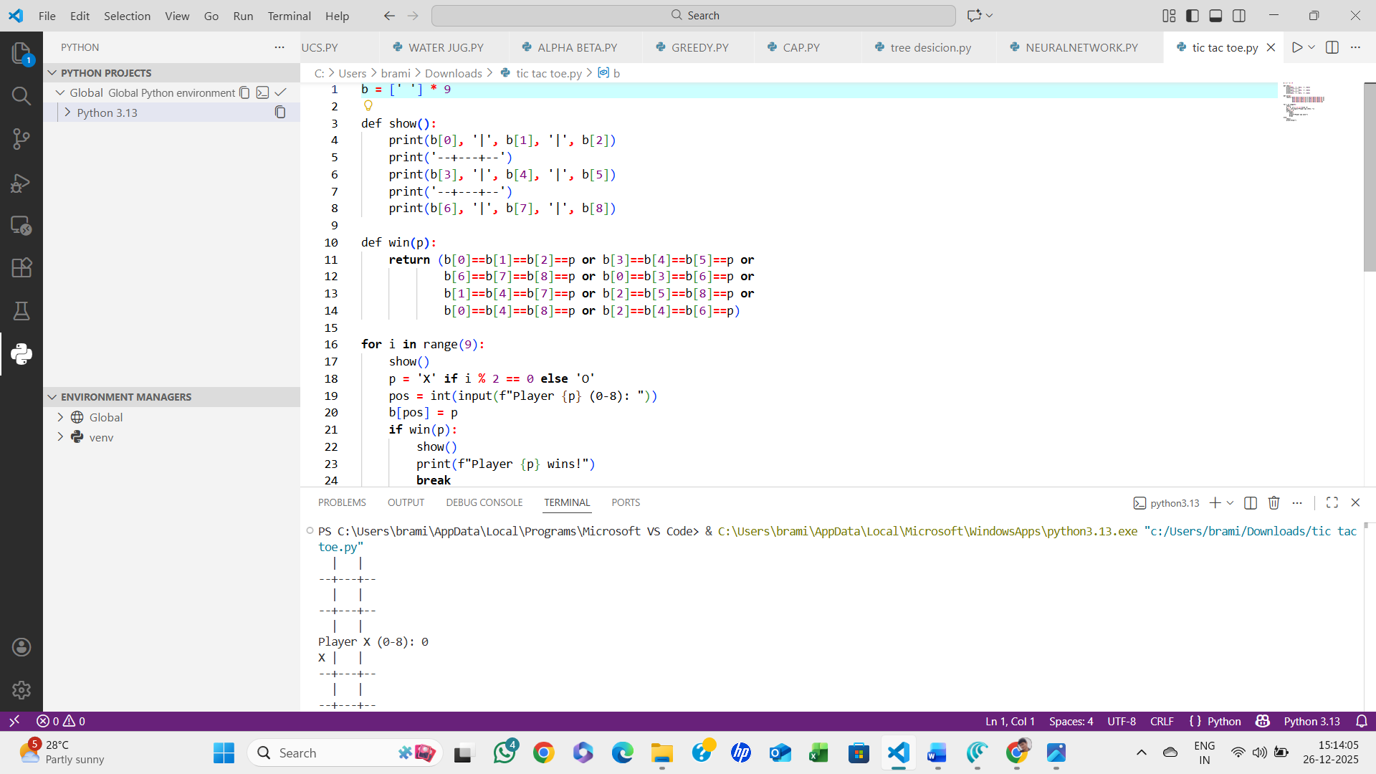
Algorithm:
- Initialize an empty board of 9 positions.
- Display the board to the players.
- Loop for 9 turns:
  - Determine current player (X or O).
  - Get the player’s move (position 0–8).
  - Update the board with the player’s symbol.
  - Check for win:
    - Check all rows, columns, and diagonals for 3 identical symbols.
    - If a player wins, declare winner and end the game.
- If no winner after 9 moves, declare a draw.
- Stop.

